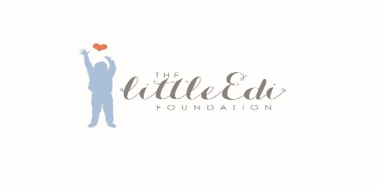

The Little Edi Foundation
Sponsorship and Gift Aid Declaration Form

Name:

Address:
Postcode:
Event

Date

Please sponsor me to raise money for The Little Edi Foundation, a charity which aims to raise funds for their UK Youth Project which helps feed, clothe and educate some of the most disadvantaged children in Europe, three of the things we take for granted every day. Their aim is to give these children a chance for the future and give support to their families enabling them to develop their potential and make a difference in the world.

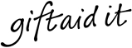

Gift Aid your donation and every pound you donate could have an extra 25 pence added to it from the Inland Revenue.

To Gift Aid your donation, you must be a UK tax payer and pay at least as much Income Tax (and/or Capital Gains Tax) as the amount of tax reclaimed by The Little Edi Foundation in the Tax year.

Full Name | Address  (We require your full address and post code to be able to claim Gift Aid) | Postcode | Amount sponsored | Gift Aid  (Please tick) | Donation Received  (Please tick)

The Little Edi Foundation Registered Charity No. 1169242
F.07

Full Name | Address  (We require your full address and post code to be able to claim Gift Aid) | Postcode | Amount sponsored | Gift Aid  (Please tick) | Donation Received  (Please tick)
Please make cheques payable to ‘The Little Edi Foundation.’ |  | Total Amount | £

Thanks for your support!
The Little Edi Foundation Registered Charity No. 1169242
F.07

